**Git : Case Study – GitFlow WorkFlow :**

**To Do : Problem Statement :-**

You work as a Devops Architect in Zendriix Softwares. The company has been struggling to manage their product releases. The releases should happen on 25th of every month. Suggest a Git Workflow Architecture for this requirement. Simulate this workflow, by creating a pseudo code files and branches, and upload the same to your GitHub Account.

As a part of solution, share the link to your GitHub repository.

**Solution :**

mkdir csgit

cd csgit

git init

git remote add origin git@github.com:sinhatushar17/Ipt-d.ops-Assignments.git

**creating pseudocode :-**

touch pseudocode.txt

git add .

git commit -m "pseudocode committed."

//now we can create branches.

git branch develop

git branch feature1

git branch feature2

git branch // develop, feature1,feature2, * master

git checkout feature1

touch feature1.txt

git add .

commit -m "feature1.txt pushed" //feature1.txt pushed

git checkout feature2

touch feature2.txt

git add .

commit -m "feature2.txt pushed" //feature2.txt pushed

git checkout develop

git merge feature1

git merge feature2

ls //feature1.txt feature2.txt pseudocode.txt

git checkout master

Now merging develop branch to master branch. -

git merge master

git merge develop

**//now pushing to github repository.**

git push -f origin --all

//replaced old fles with new ones Forcefully (-f : deleted old files & pushed new files forcefully to branch repo)

**According to the case study question** : The releases should happen on 25th of every month.

***This pushing Release should be done manually on 25th of every month.***

So, we have made the required workflow architecture to do so.

The architecture looks like this –

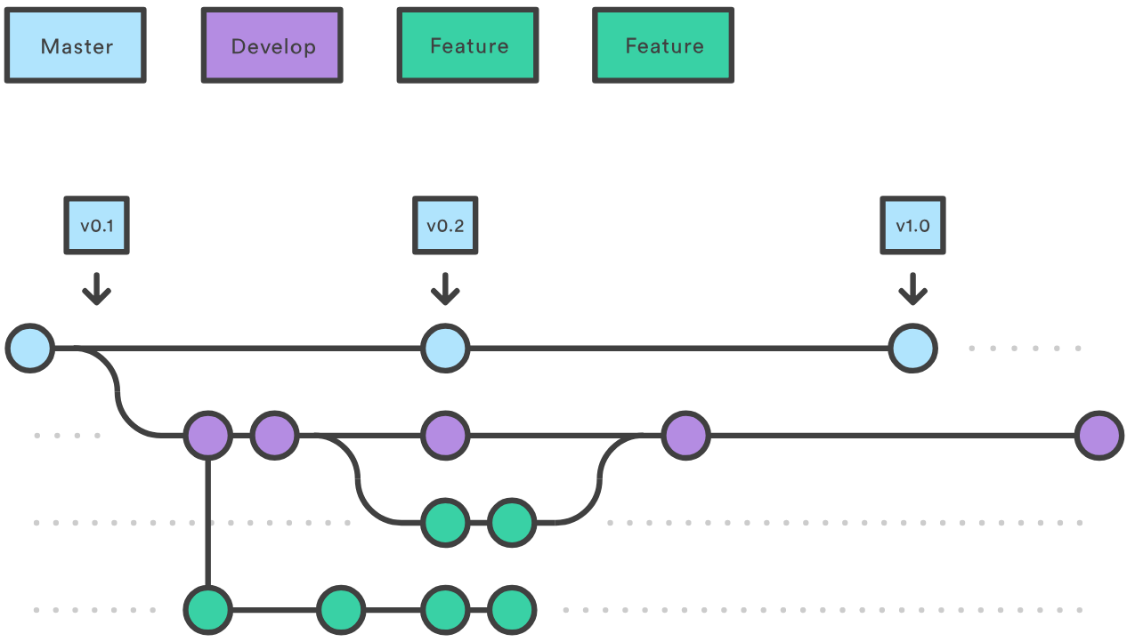

-----------------------------------------------------------------------------------------------------

**Submitted By : Tushar Sinha**

**Email ID :** [**sinhatushar17@gmail.com**](mailto:sinhatushar17@gmail.com)

**Enrolled in the “DevOps Architect Master’s Training Program”.**